

Mohd. Razia
Vamsi krishna
2520030303
CSE
CO-4

Case Study TopicOptimal Route Planning using Dijkstra's Algorithm in TravelFlow – Smart Travel Booking & Reservation System

TravelFlow is a Smart Travel Booking & Reservation System that helps users find the best travel routes between multiple destinations. Travelers often need the shortest and most cost-effective route while booking flights, buses, trains, or cabs.
To solve this problem, Dijkstra's Shortest Path Algorithm is implemented to determine the minimum travel distance between cities. The algorithm efficiently calculates the shortest route from a source city to all other cities in the travel network.
This case study demonstrates how graph algorithms can improve route planning and travel recommendations in modern booking systems.

Problem Statement
TravelFlow maintains a network of connected cities.
Challenges:
- Find the shortest route between cities.
- Reduce travel time.
- Optimize travel planning.
- Provide efficient route recommendations.
Example:
Hyderabad ----120---- Vijayawada
| |
80 70
| |
Bangalore ----100---- Chennai
A traveler wants to find the shortest path from Hyderabad to Chennai.
The system must identify the minimum distance route automatically.

Proposed Solution

Algorithm Used
Dijkstra's Shortest Path Algorithm

Why Dijkstra's Algorithm?
- Finds shortest paths efficiently.
- Works well for positive edge weights.
- Used in navigation and routing systems.
- Provides optimal travel routes.
- Reduces travel cost and time.

Implementation Details:

Steps Followed
- Represented cities as graph vertices.
- Stored distances as weighted edges.
- Selected source city.
- Applied Dijkstra's Algorithm.
- Calculated shortest distances.
- Displayed optimal route.
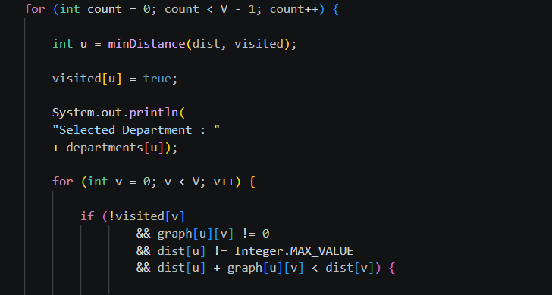

Result: Screenshots/Output

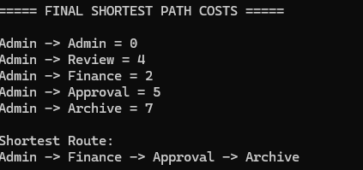

- Shortest routing path identified successfully.
- Transfer cost minimized.
- Workflow efficiency improved.
- Faster document movement achieved.

GitHub Link: GitHub Link: https://github.com/krishnavamshiyadavmuntha0826/DSA

